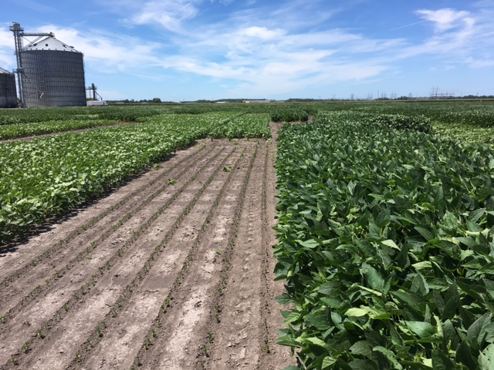/Users/cpboyce/Desktop/NCCooperativeExtension-logo_EMAIL-SIG.jpg

* Insect resistance management
* Planting date for maturity groups 3 & 4
* Nitrogen, phosphorus, potassium, and sulfur fertility at R1 for maturity groups 3 & 4
* Nitrogen, phosphorus, potassium, and sulfur fertility at planting for maturity groups 3 & 4
* Seeding rates for maturity groups 3, 4, and 5
* Row widths for maturity groups 3 & 4
* Soybean trials evaluating maturity groups 4 & 5 varieties
* Foliar fungicide test
* Nutrient content at certain growth stages for maturity groups 3 & 4
* Variety X Management System
* Potash rates
* Desiccants

Topics Covered

Soybean

Featured Commodity

Comments by Participants

* I am a junior in high school and interested in an ag career
* Great field day excellent speakers
* It was awesome can't wait until next year
* Great field day thank you for putting this event on each year
* Very well organized and great marketing. Great job
* Good job well put together

NC Spuds, Inc. & Perdue Agribusiness

Elizabeth City, NC

**2018 Northeast Ag Expo Summer Field Day**

To provide to growers and other members of the agricultural community up-to-date information on crops, technologies, and crop production related practices.

The North Carolina Cooperative Extension Centers of Camden, Chowan, Currituck, Gates, Pasquotank, and Perquimans, The N.C. Soybean Producers Association, Inc., as well as farmers, other commodity groups, and agribusinesses.

The Objective

Impacts of Event

The Partners

The Participants

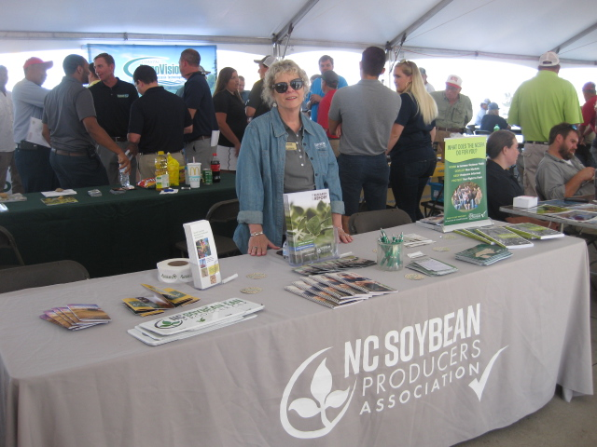

* 280 in attendance with a total of 308,012 acres of cropland and 248,010 acres of soybean represented
* 75 farmers received pesticide license credits
* 35 commercial pesticide applicators received a total of 75 credits, which preserved a total of $217,000 in wages and saved them $1,200

in registration fees

* 11 certified crop advisors received a total of 22 hours of continuing education credits
* When asked if they had benefited from information on soybean provided at previous field days, the total economic value to the agricultural community of northeast North Carolina was $2,501,298.00

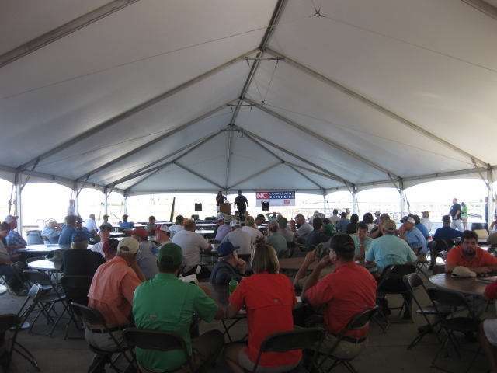

The charts are based on 127 evaluations completed out of 280 participants, which is a return rate of 45%.